Mr. Visca – AP Calculus AB
Unit 4: Applications of derivatives Review Notes

Extreme Values

The _____________ and ______________ of the function. On the graph, they are the

____________________ and _________________.

Find Extreme values algebraically by: __________________________________

These are called: ________________________________

Ex. Find the mins and maxes, and where they occur of the following function,
$y=\frac{1}{3}x^{3}+6x^{2}+27x$

Mean Value Theorem for Derivatives

$\frac{f\left(b\right)-f(a)}{b-a}=f'(c)$ If f(x) is differentiable on the interval [a,b], then there exists a point “c”
where __________________________________________________

Show that the function f(x) = x² satisfies the hypothesis of the mean value theorem on the interval [0,2].

Graphs: f’(x) is slope & f’’(x) is concavity

First Derivative indicates ________________ of graph of original function

_________________ is negative (downward) when f ’(x) < 0; or when f ‘ (x) is negative

_________________ is positive (upward) when f ’(x) > 0; or when f ‘ (x) is positive

_________________ changes at from positive to negative or negative to positive at CRITICAL POINTS; this is where f ‘ (x) __________________________________

Second Derivative indicates ________________ of graph of original function

_________________ is negative (frown face) when f “(x) < 0; or when f “ (x) is negative

_________________ is positive (smiling face) when f “(x) > 0; or when f “ (x) is positive

_________________ changes at from positive to negative or negative to positive at INFLECTIONS POINTS; this is where f “ (x) __________________________________

Find any extreme values, points of inflection, and sketch the graph of y = x³ - 3x² + 4.

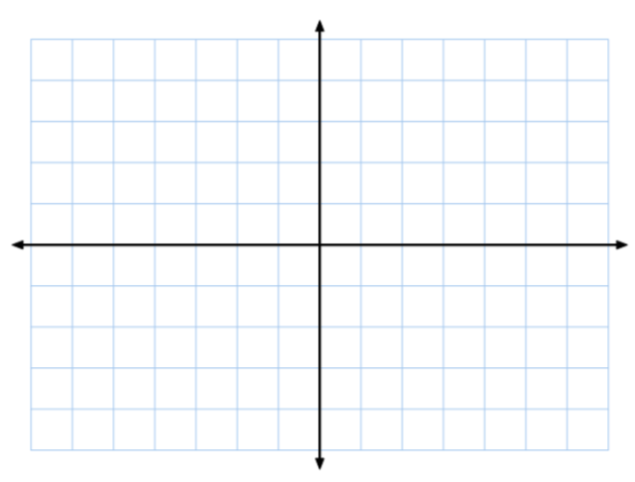

Related Rates:

Dimensions or measurements that are changing with respect to time: a change in radius, height, etc…

The radius of a sphere is decreasing at a rate of 0.5 cm/sec. What is the rate of change of its volume when r = 20?

A 10-foot ladder leans against a vertical wall. The base of the ladder is pulled away from the wall at a constant rate of 2 ft/sec. At what rate is the top of the ladder falling when the base of the ladder is 8 feet from the wall?

Unit 4 REVIEW Practice Problems
Show all your work! Allowed to use a calculator with any problem with an “*”
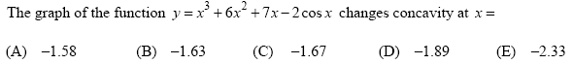
*1.

2.

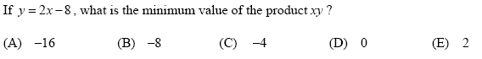
3.

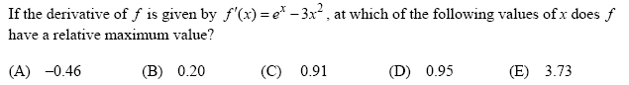
*4.

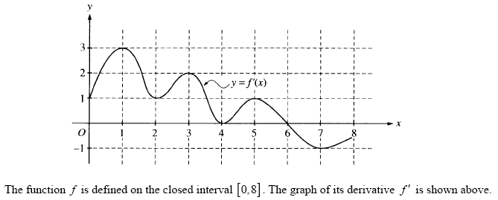
5.

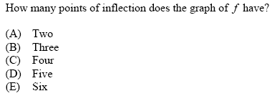

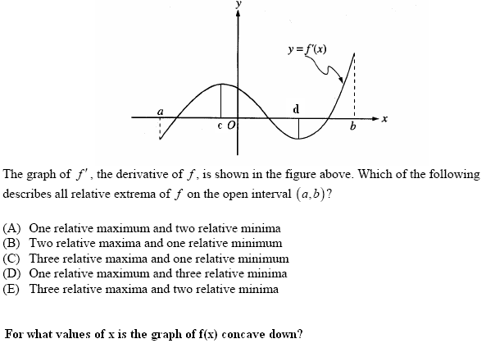
6 – 7.

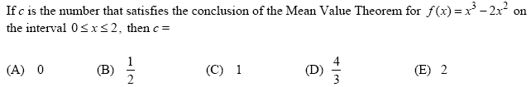
8.

9. A particle moves along a line with position x(t) = 2t³ -10t² + 14t – 11, t ≥ 0. During which
interval(s) is the particle moving to the left?

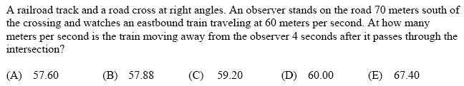
10.

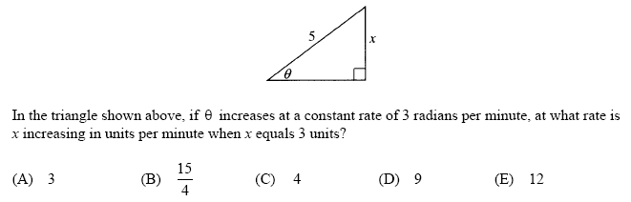
11.

